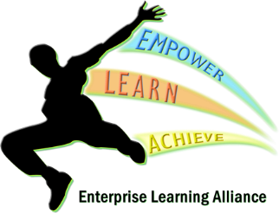

Enterprise learning alliance:
Pupil Voice meeting:
22/4/21
Staff present: NW (SLT), CE , SH (WW), CE (SW), KY (NW)
Pupils:
SW x 3, NW x 1, WW x 2
Centre discussions:
Westwood:
- WW discussed a break after the first lesson, possibly outside. NW explained that the break would have to be inside, SW and NW already have a drink and biscuit break.
- WW would like better trips and enrichment, especially yr 11’s at the end of the year, possibly a theme park.

Southwood:
- SW would like the love to shop vouchers to be on an online reloadable card.
- Is there a possibility of XBOX/PS4 vouchers as the rewards on class charts, NW stated he will look into this.
- SW would also like termly behaviour trips, for good behaviour, NW said he was happy with this, and for the pupils and CE to discuss with JN.
- SW would like to have puddings back at Southwood school lunches. NW stated he will discuss with SLT.
- SW would like to go to Thorpe Park for year 11 end of year trip.
- SW would like some bean bags for the new chill out room. NW stated to CE to contact LF at Northwood, as he has some that he does not use.

Northwood:
- NW would like to have PE bottoms for Sports, NW stated WW have some they do not use, brand new. KY to speak to SC about taking some to NW.
- NW would like to have stress balls back as rewards through class charts. NW to order more.
- NW would like more external PE lessons, football in the park, or other sports. NW to discuss with LF.

